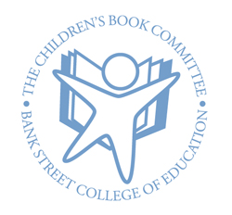
The Children’s Book Committee
Bank Street College of Education
610 West 112th Street
New York, NY 10025

BOOK REVIEW FORM
Please save and email this review to: youngreviewers@bankstreet.edu
Thank you!

DATE: _____________

REVIEWER: ____________________________ AGE: _________ GRADE: __________________________________

TITLE OF BOOK: ___________________________________________________________________________________

AUTHOR: ___________________________________________________________________________________________

How would you rate this book? (Highlight one of the following)
didn’t like just so-so good excellent

What makes this book special or different? What did you like most? What did you like least?

If there are illustrations in this book, how did they go with the story? Did you like them?

Would you recommend this book? If so, for what age group?

